
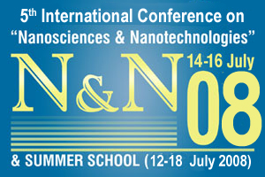

Monday 14 July 2008
DAY 1

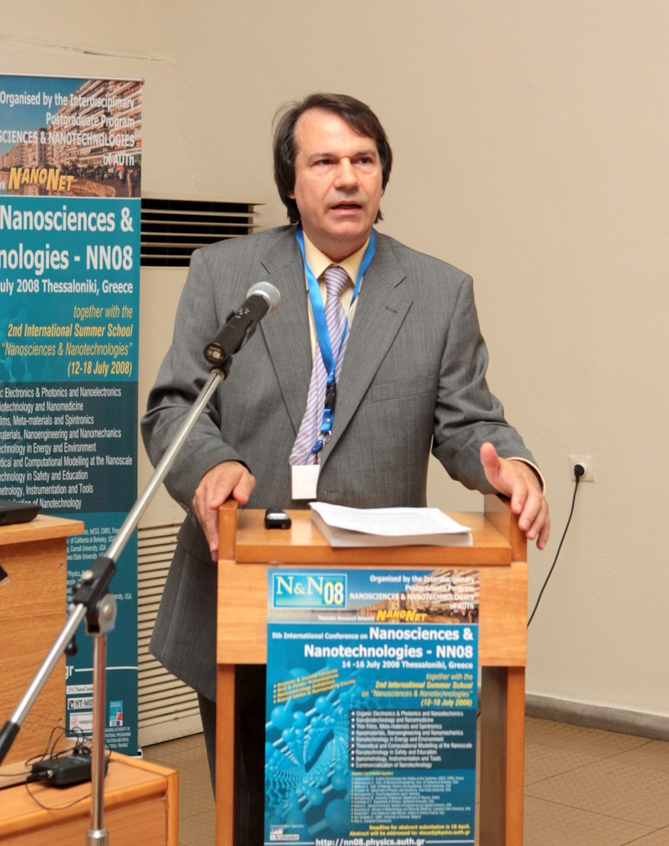
Opening Ceremony

The 5th Conference of Nanosciences and Nanotechnologies started today, being held by the Physics Department of the Aristotle University of Thessaloniki (A.U.Th.). Following the annual tradition, the Conference gathered leading scientists, engineers and industry experts from more than 40 countries worldwide.
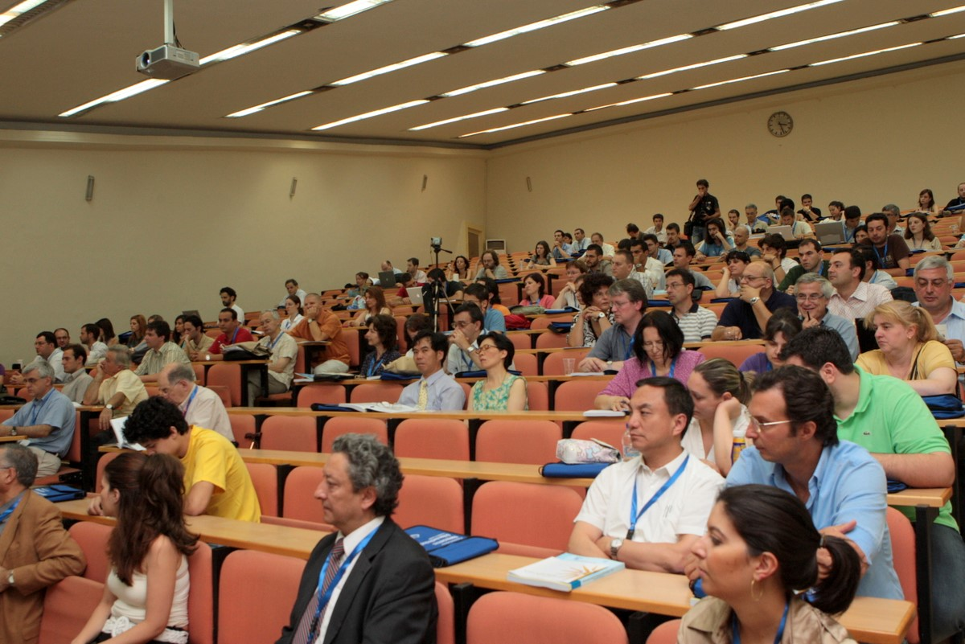

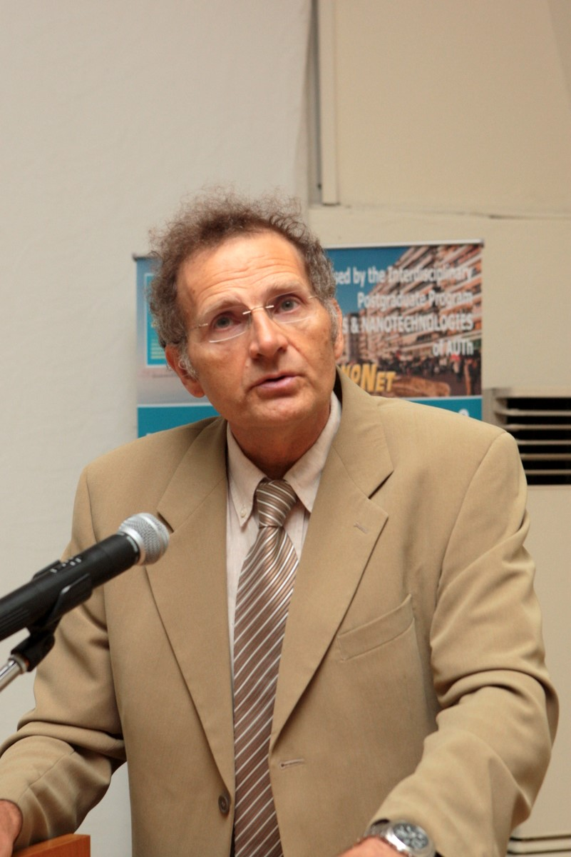
The opening ceremony started at approximately 9 am with a speech given by Professor S. Logothetidis, Chairman of the NN08 organizing committee and of the Physics Dept. of A. U. Th. The Professor welcomed everyone and referred to the previous Workshops and the recent, satellite event, the International Symposium which took place at the Pallini Beach Hotel (9-11 July) and its topic was Flexible Organic Electronics (ISFOE).

The opening remarks were followed by a brief speech from the Rector of A. U. Th. and Professor of the Faculty of Medicine, Dr Manthos Anastasios, who made a brief reference to the history of Thessaloniki.

Plenary Talk

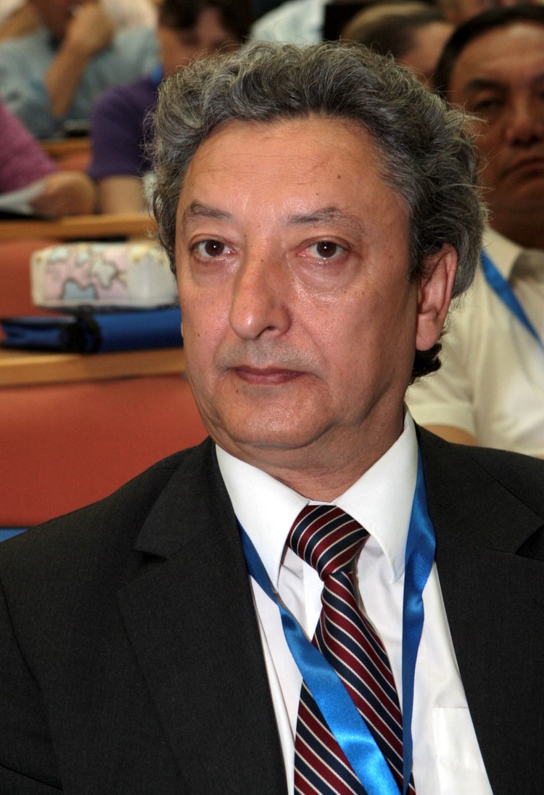
1st Session: Organic Electronics & Photonics and Nanoelectronics

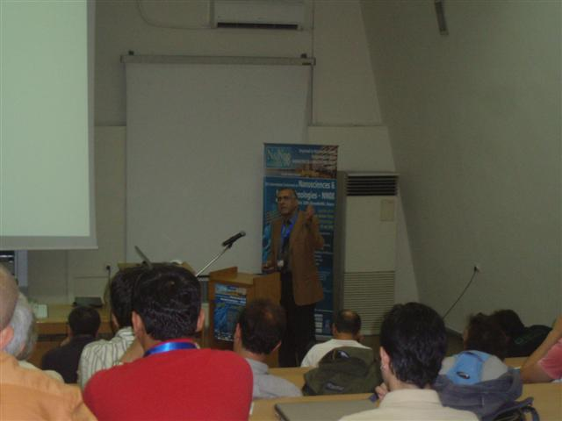
The Plenary Talk titled “Quantum Transport in Molecules and Nanostructures” was given by Professor Sokrates T. Pantelides, from the Physics Dept. of the Vanderbilt University at Nashville, Tennessee, USA. The Professor focused on his work in transport in Nano-MOSFETs, in transport molecules and in the AC-response of graphene nano-nano-ribbons.

Chairmen of the first session of the Conference were Professors Hadziioannou G and Kaxiras E.. This session commenced with the work of the Invited Speaker, Dr. Mark Boukerche, who talked about European Supported Activities. In his talk “European Supported Activities in Micro- & Nanosystems R&D. Status & Outlook” Dr. Boukerche gave special attention to the European Technology Platforms (ETPs), which are a new concept that will promote industrial and academic research collaborations and such ETPs relevant to nanotechnology nowadays are ENIAC, EPOSS, MINAM and others.

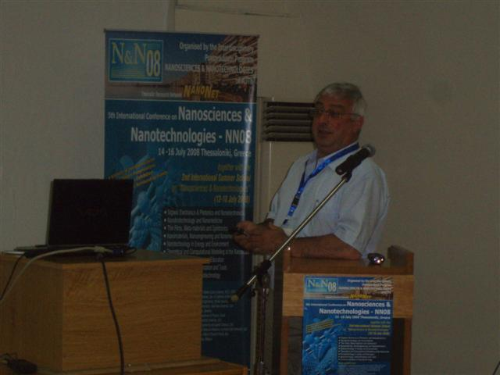
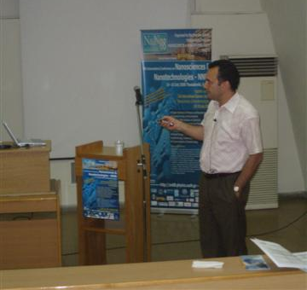
Professor Hadziioannou from the University Louis Pasteur of Strasburg concentrated into “Semiconducting Block Copolymers: Optimized Synthesis and Processing for Efficient Photovoltaic Devices”. During the presentation, he demonstrated a video with a flexible display and gave special importance to the fact that in one hour the Earth is struck by an energy of 430 EJ originating from the sun, which almost equals to the current annual world need. Though today organic materials contribute to pollution and global warming, tomorrow they may produce clean energy, the speaker pointed out.
“Photolithographic Patterning of Organic Semiconductors” was the topic of Professor Malliaras’s talk, from Cornell University of the USA. Professor Malliaras and his team propose new approaches for the photolithographic patterning of organic materials. In specific, one such technique is called Hydrofluorethens (HFEs), which is an

2nd Session: Nanotechnology in Energy and Environment

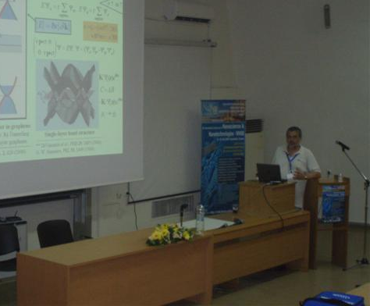
3rd Session: Theoretical and Computational Modeling at the Nanoscales

environmentally friendly technique and simultaneously it is benign to organics. In addition, the Parylene technique is also compatible to organics, as there is no specialty for it in chemicals.

Professors Cefalas and Konstandopoulos were the chairmen of the second session, which began with a talk by the invited speaker, Dr. Giannoules, entitled “Converting Photons into Solar Power Business” who concentrated on solar energy as the alternative clean source of energy.
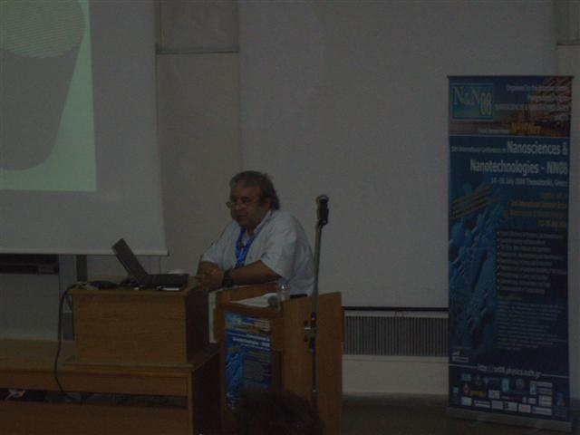
Professor Konstandopoulos gave a talk titled “Nanoparticle Technologies for Emission Control and Clean Energies” which focused on coated monolithic reactors for environmental and energy applications, giving special attention to their present work at APT Lab of CPERI/CERTH, the Wall-Flow Diesel Particulate Filter (DPF). The team at APT Lab research on solar thermochemical technologies so as to find applications in clean, green energy.

The 3rd and last session for the first day of the Conference was involved with theoretical approaches and computational modeling. This session was chaired by Dr. Laskarakis and Professor Vassilopoulos.
Professor Vassilopoulos from Concordia University was also an invited speaker and opened this last session. His presentation entitled “Direction-Dependent Tunneling Through Graphene Nanostructures” concentrated on the transmission through graphene-based nanostructures as a function of the incident wave vector and other parameters, such as widths, well, depths, etc. The results of this work revealed that Klein tunneling can be controlled.

Poster Session I

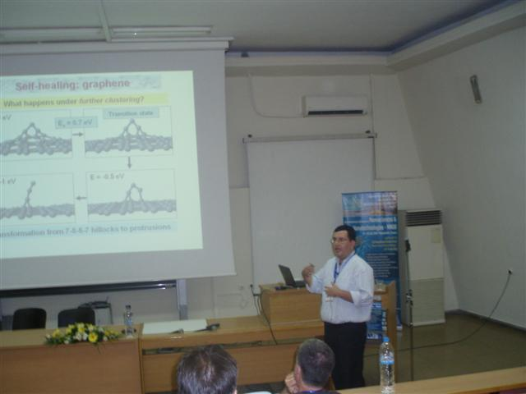
Graphene was also the content of the talk given by Dr. L. Tsetseris “Self-Healing of Defective Graphene and Carbon Nanotubes”. In collaboration with Professor S. T. Pantelides, he reported results of first-principles calculations on key structures and superstructures of carbon self-interstitials atoms on graphene, graphite and CNT’s and also described the self-healing processes and mechanisms.

The Poster Session I took place after the lunch break, from 2pm to 3pm. The 52 posters presented, were relevant to the oral presentations that were given during the day, so there were posters concerning Organic Electronics & Photonics and Nanoelectronics, Nanotechnology in Energy and Environment and Theoretical and Computational Modeling at the Nanoscale. The participants had the opportunity discuss and network, while learning interesting experimental results from various team works and explore new fields of the Nanosciences and Nanotechnologies.
